Co1

EXP. 2 — QUESTION A

TRANSMISSION-LINE/TWO-PORT S-PARAMETERS

1. AIM
To model a 50 Ω microwave two-port network of length 50 mm and simulate its S-parameters (S11, S12, S21 and S22) over the frequency range of 8–12 GHz with a center frequency of 10 GHz. To calculate return loss, insertion loss and transmission efficiency at 10 GHz and compare the simulated values with the ideal 50 Ω matched reference.

2. SOFTWARE USED
MATLAB

3. MATLAB CODE
clc;
clear;
close all;

%% EXPERIMENT 2: MICROWAVE TRANSMISSION-LINE S-PARAMETERS

% INPUT PARAMETERS
f0 = 10e9; % Operating frequency: 10 GHz
Z0 = 50; % Reference impedance: 50 ohms
ZL = 50; % Load impedance: 50 ohms
fstart = 8e9; % Start frequency: 8 GHz
fstop = 12e9; % Stop frequency: 12 GHz
L = 50e-3; % Network length: 50 mm
c = 3e8; % Speed of light (m/s)

% MODEL ASSUMPTIONS
% The assignment does not specify line loss or characteristic impedance.
% Assume a slightly mismatched, lossy line to demonstrate frequency response.
Zline = 55; % Assumed line characteristic impedance (ohms)
loss10_dB = 1.5; % Assumed line insertion loss at 10 GHz (dB)

%% FREQUENCY SWEEP
f = linspace(fstart, fstop, 4001);
N = length(f);

S11 = zeros(1,N);
S21 = zeros(1,N);
S12 = zeros(1,N);
S22 = zeros(1,N);

%% CALCULATE S-PARAMETERS USING ABCD MATRIX
for k = 1:N

% Frequency-dependent attenuation
% Assumes attenuation varies approximately with sqrt(f)
alpha_dB = loss10_dB * sqrt(f(k)/f0);
alpha = alpha_dB * log(10)/20; % Np for voltage-wave amplitude

beta = 2*pi*f(k)/c; % Phase constant
gamma = alpha + 1j*beta;

% Transmission-line ABCD parameters
A = cosh(gamma*L);
B = Zline*sinh(gamma*L);
C = sinh(gamma*L)/Zline;
D = cosh(gamma*L);

% Convert ABCD to S-parameters, equal 50-ohm port references
den = A + B/Z0 + C*Z0 + D;

S11(k) = (A + B/Z0 - C*Z0 - D)/den;
S21(k) = 2/den;
S12(k) = 2*(A*D - B*C)/den;
S22(k) = (-A + B/Z0 - C*Z0 + D)/den;
end

%% FIND VALUES AT 10 GHz
[~,idx10] = min(abs(f-f0));

S11_10 = S11(idx10);
S21_10 = S21(idx10);
S12_10 = S12(idx10);
S22_10 = S22(idx10);

S11_dB_10 = 20*log10(max(abs(S11_10),eps));
S21_dB_10 = 20*log10(max(abs(S21_10),eps));

% Return loss and insertion loss
RL_10 = -S11_dB_10;
IL_10 = -S21_dB_10;

% Transmission efficiency
eta_10 = abs(S21_10)^2*100;

%% FIND BEST OPERATING FREQUENCY
S11_dB = 20*log10(max(abs(S11),eps));
S21_dB = 20*log10(max(abs(S21),eps));

% Best matching: minimum reflection magnitude
[~,idx_best_match] = min(abs(S11));

% Best transmission: maximum transmission magnitude
[~,idx_best_trans] = max(abs(S21));

f_best_match = f(idx_best_match);
f_best_trans = f(idx_best_trans);

%% DISPLAY INPUT PARAMETERS
fprintf('\n========== INPUT PARAMETERS ==========\n');
fprintf('Operating frequency : %.2f GHz\n',f0/1e9);
fprintf('Reference impedance : %.2f ohms\n',Z0);
fprintf('Frequency sweep : %.2f to %.2f GHz\n',...
fstart/1e9,fstop/1e9);
fprintf('Network length : %.2f mm\n',L*1e3);
fprintf('Load termination : %.2f ohms\n',ZL);
fprintf('Assumed line Zc : %.2f ohms\n',Zline);
fprintf('Assumed loss at 10 GHz: %.2f dB\n',loss10_dB);

%% DISPLAY OUTPUT PARAMETERS AT 10 GHz
fprintf('\n======= OUTPUT AT 10 GHz =======\n');
fprintf('S11 = %.5f %+.5fj\n',real(S11_10),imag(S11_10));
fprintf('S12 = %.5f %+.5fj\n',real(S12_10),imag(S12_10));
fprintf('S21 = %.5f %+.5fj\n',real(S21_10),imag(S21_10));
fprintf('S22 = %.5f %+.5fj\n',real(S22_10),imag(S22_10));

fprintf('\nS11 magnitude = %.2f dB\n',S11_dB_10);
fprintf('S21 magnitude = %.2f dB\n',S21_dB_10);
fprintf('Return loss = %.2f dB\n',RL_10);
fprintf('Insertion loss= %.2f dB\n',IL_10);
fprintf('Efficiency = %.2f %%\n',eta_10);

%% IDEAL MATCHED REFERENCE
fprintf('\n======= IDEAL 50-OHM REFERENCE =======\n');
fprintf('S11 = 0\n');
fprintf('S22 = 0\n');
fprintf('|S21| = 1 (0 dB)\n');
fprintf('|S12| = 1 (0 dB)\n');
fprintf('Return loss = Infinity\n');
fprintf('Insertion loss = 0 dB\n');
fprintf('Efficiency = 100 %%\n');

%% DISPLAY OPTIMUM FREQUENCIES
fprintf('\n======= OPTIMUM FREQUENCY =======\n');

fprintf('Minimum |S11| frequency = %.4f GHz\n',...
f_best_match/1e9);
fprintf('S11 at best match = %.2f dB\n',...
S11_dB(idx_best_match));
fprintf('Return loss at match = %.2f dB\n',...
-S11_dB(idx_best_match));
fprintf('S21 at best match = %.2f dB\n',...
S21_dB(idx_best_match));

fprintf('\nMaximum |S21| frequency = %.4f GHz\n',...
f_best_trans/1e9);
fprintf('S11 at best transmission = %.2f dB\n',...
S11_dB(idx_best_trans));
fprintf('S21 at best transmission = %.2f dB\n',...
S21_dB(idx_best_trans));
fprintf('Return loss there = %.2f dB\n',...
-S11_dB(idx_best_trans));
fprintf('Insertion loss there = %.2f dB\n',...
-S21_dB(idx_best_trans));

%% PLOT ALL S-PARAMETERS IN ONE FIGURE
figure('Name','Experiment 2: S-Parameter Analysis',...
'NumberTitle','off');

subplot(2,2,1);
plot(f/1e9,S11_dB,'LineWidth',1.6);
hold on;
plot(f_best_match/1e9,S11_dB(idx_best_match),'ro',...
'MarkerFaceColor','r');
grid on;
xlabel('Frequency (GHz)');
ylabel('|S11| (dB)');
title('Input Reflection S11');

subplot(2,2,2);
plot(f/1e9,S21_dB,'LineWidth',1.6);
hold on;
plot(f_best_trans/1e9,S21_dB(idx_best_trans),'ro',...
'MarkerFaceColor','r');
grid on;
xlabel('Frequency (GHz)');
ylabel('|S21| (dB)');
title('Forward Transmission S21');

subplot(2,2,3);
plot(f/1e9,20*log10(max(abs(S12),eps)),'LineWidth',1.6);
grid on;
xlabel('Frequency (GHz)');
ylabel('|S12| (dB)');
title('Reverse Transmission S12');

subplot(2,2,4);
plot(f/1e9,20*log10(max(abs(S22),eps)),'LineWidth',1.6);
grid on;
xlabel('Frequency (GHz)');
ylabel('|S22| (dB)');
title('Output Reflection S22');

sgtitle('50-mm Microwave Transmission Line: 8-12 GHz');

4. OUTPUT
Insert the MATLAB output screenshots showing the S-parameter curves over 8–12 GHz and the simulated values at 10 GHz.
Record the following parameters:
- S11: Input reflection coefficient
- S12: Reverse transmission coefficient
- S21: Forward transmission coefficient
- S22: Output reflection coefficient
- Return loss: RL = −20 log₁₀|S11|
- Insertion loss: IL = −20 log₁₀|S21|
- Transmission efficiency: η = |S21|² × 100%

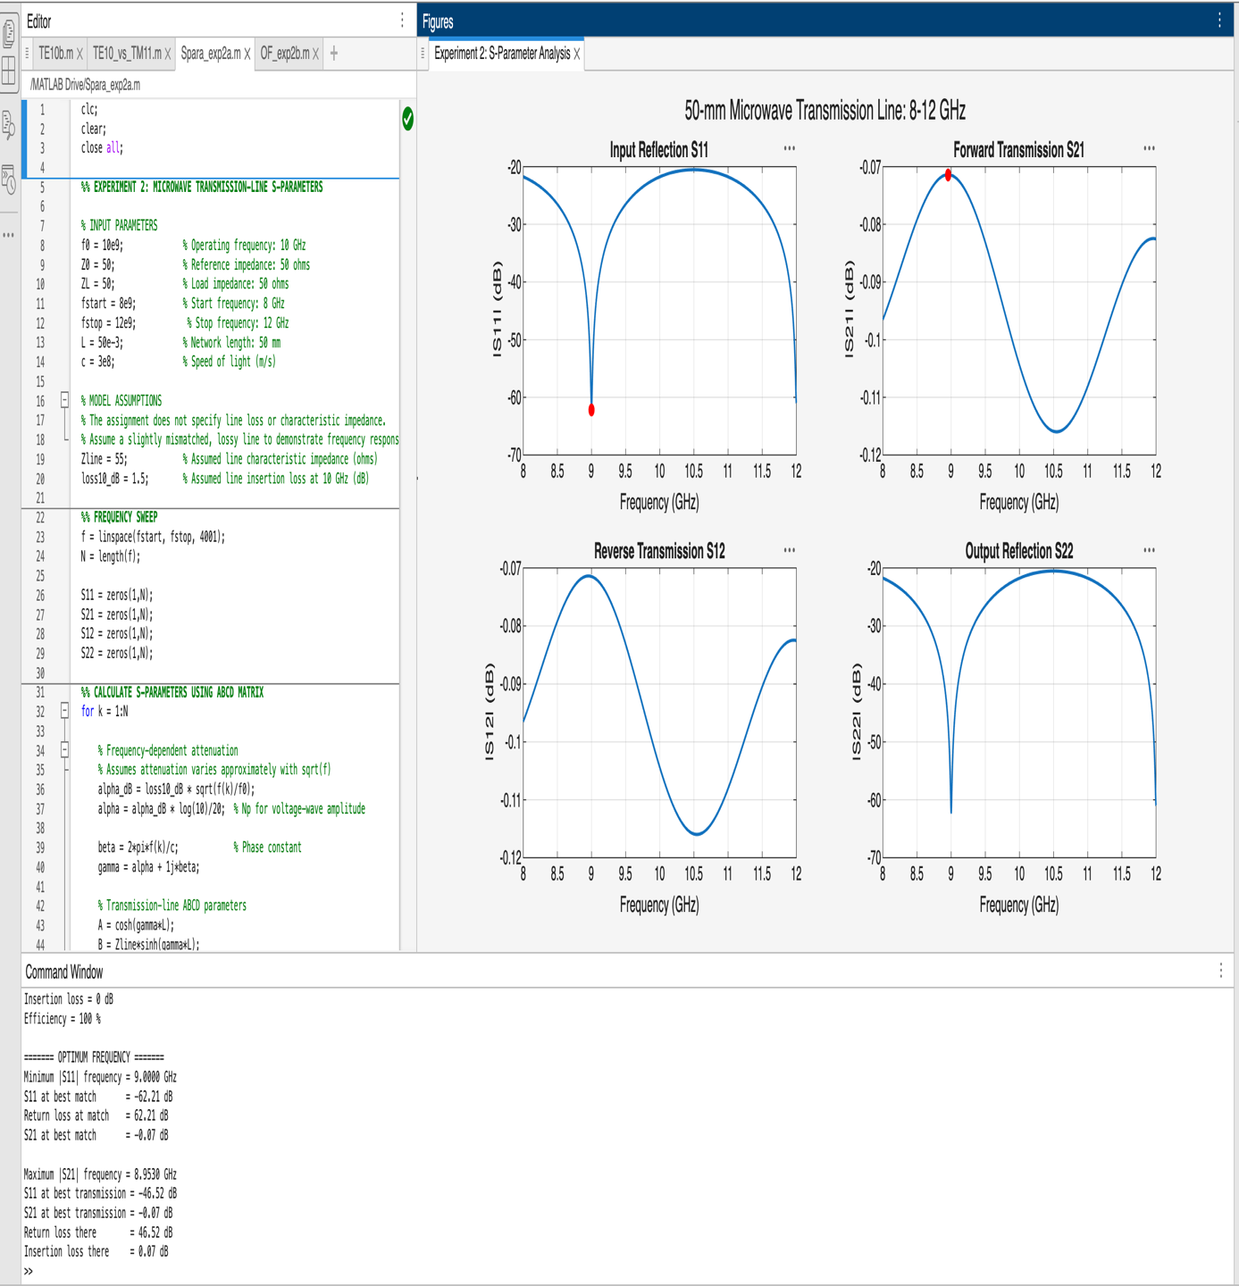

5. RESULT
The 50 Ω microwave two-port network was simulated in MATLAB over the frequency range of 8–12 GHz. The S-parameters were obtained, and the return loss, insertion loss and transmission efficiency were evaluated at 10 GHz and compared with the ideal matched reference.

